Happy New Year everyone! We have another year of sewing and crafting to look forward to, with new workshops and events at our monthly meetings. Welcome to the first newsletter of the new year. There are some reports of recent events here and I am very grateful to everyone who has contributed to this edition. I hope you will find something of interest. If you go to an event in 2026 which might interest members, I hope you will consider writing a brief report about it. Without your input there wouldn’t be much here to read! Thank you. Cat N.
  - Winter 2026
  - Number 169
Committee Members:
Chairperson: Teresa C
Treasurer: Jane S
Secretary: Sally P
Membership: Ena B
Programme Organiser & Trips: Sally P/Teresa C
Website Newsletter: Cat N
Sarah N
Nikki T
Caroline W
Website: marketsquarequilters.co.uk
Email: marketsquarequilters@gmail.com

Market Square Quilters Newsletter

Club Meetings
Brief reports of the meetings can be found on the website, along with photographs of the quilts shown in Show and Tell.
Forthcoming meetings:
January 28th 2026
Launch of Block of the Month by Cat – Lincolnshire Posy. I will also do a brief demonstration of methods of appliqué. Membership cards for 2026 will be available and we will explain this year’s programme to the group.
February 25th 2026
Harriet Riddle will be coming to talk to us on “Travels with a Sewing Machine”.
March 25th 2026
Steve Dalley is coming to talk to us about sewing machine care. Steve and his wife once owned Eastleigh Sewing, a shop in Eastleigh. He services all the Brother sewing machines for Sew Devine, although he also services other makes. He is based in Newbury.
Forthcoming Workshop January 31st
Maggie Davies will be coming to Chieveley for a Saturday workshop on Hawaiian Quilting brought up to date. At the time of writing, there was still one place available.
Quilters’ Guild Regional
Meeting October 25th 2025

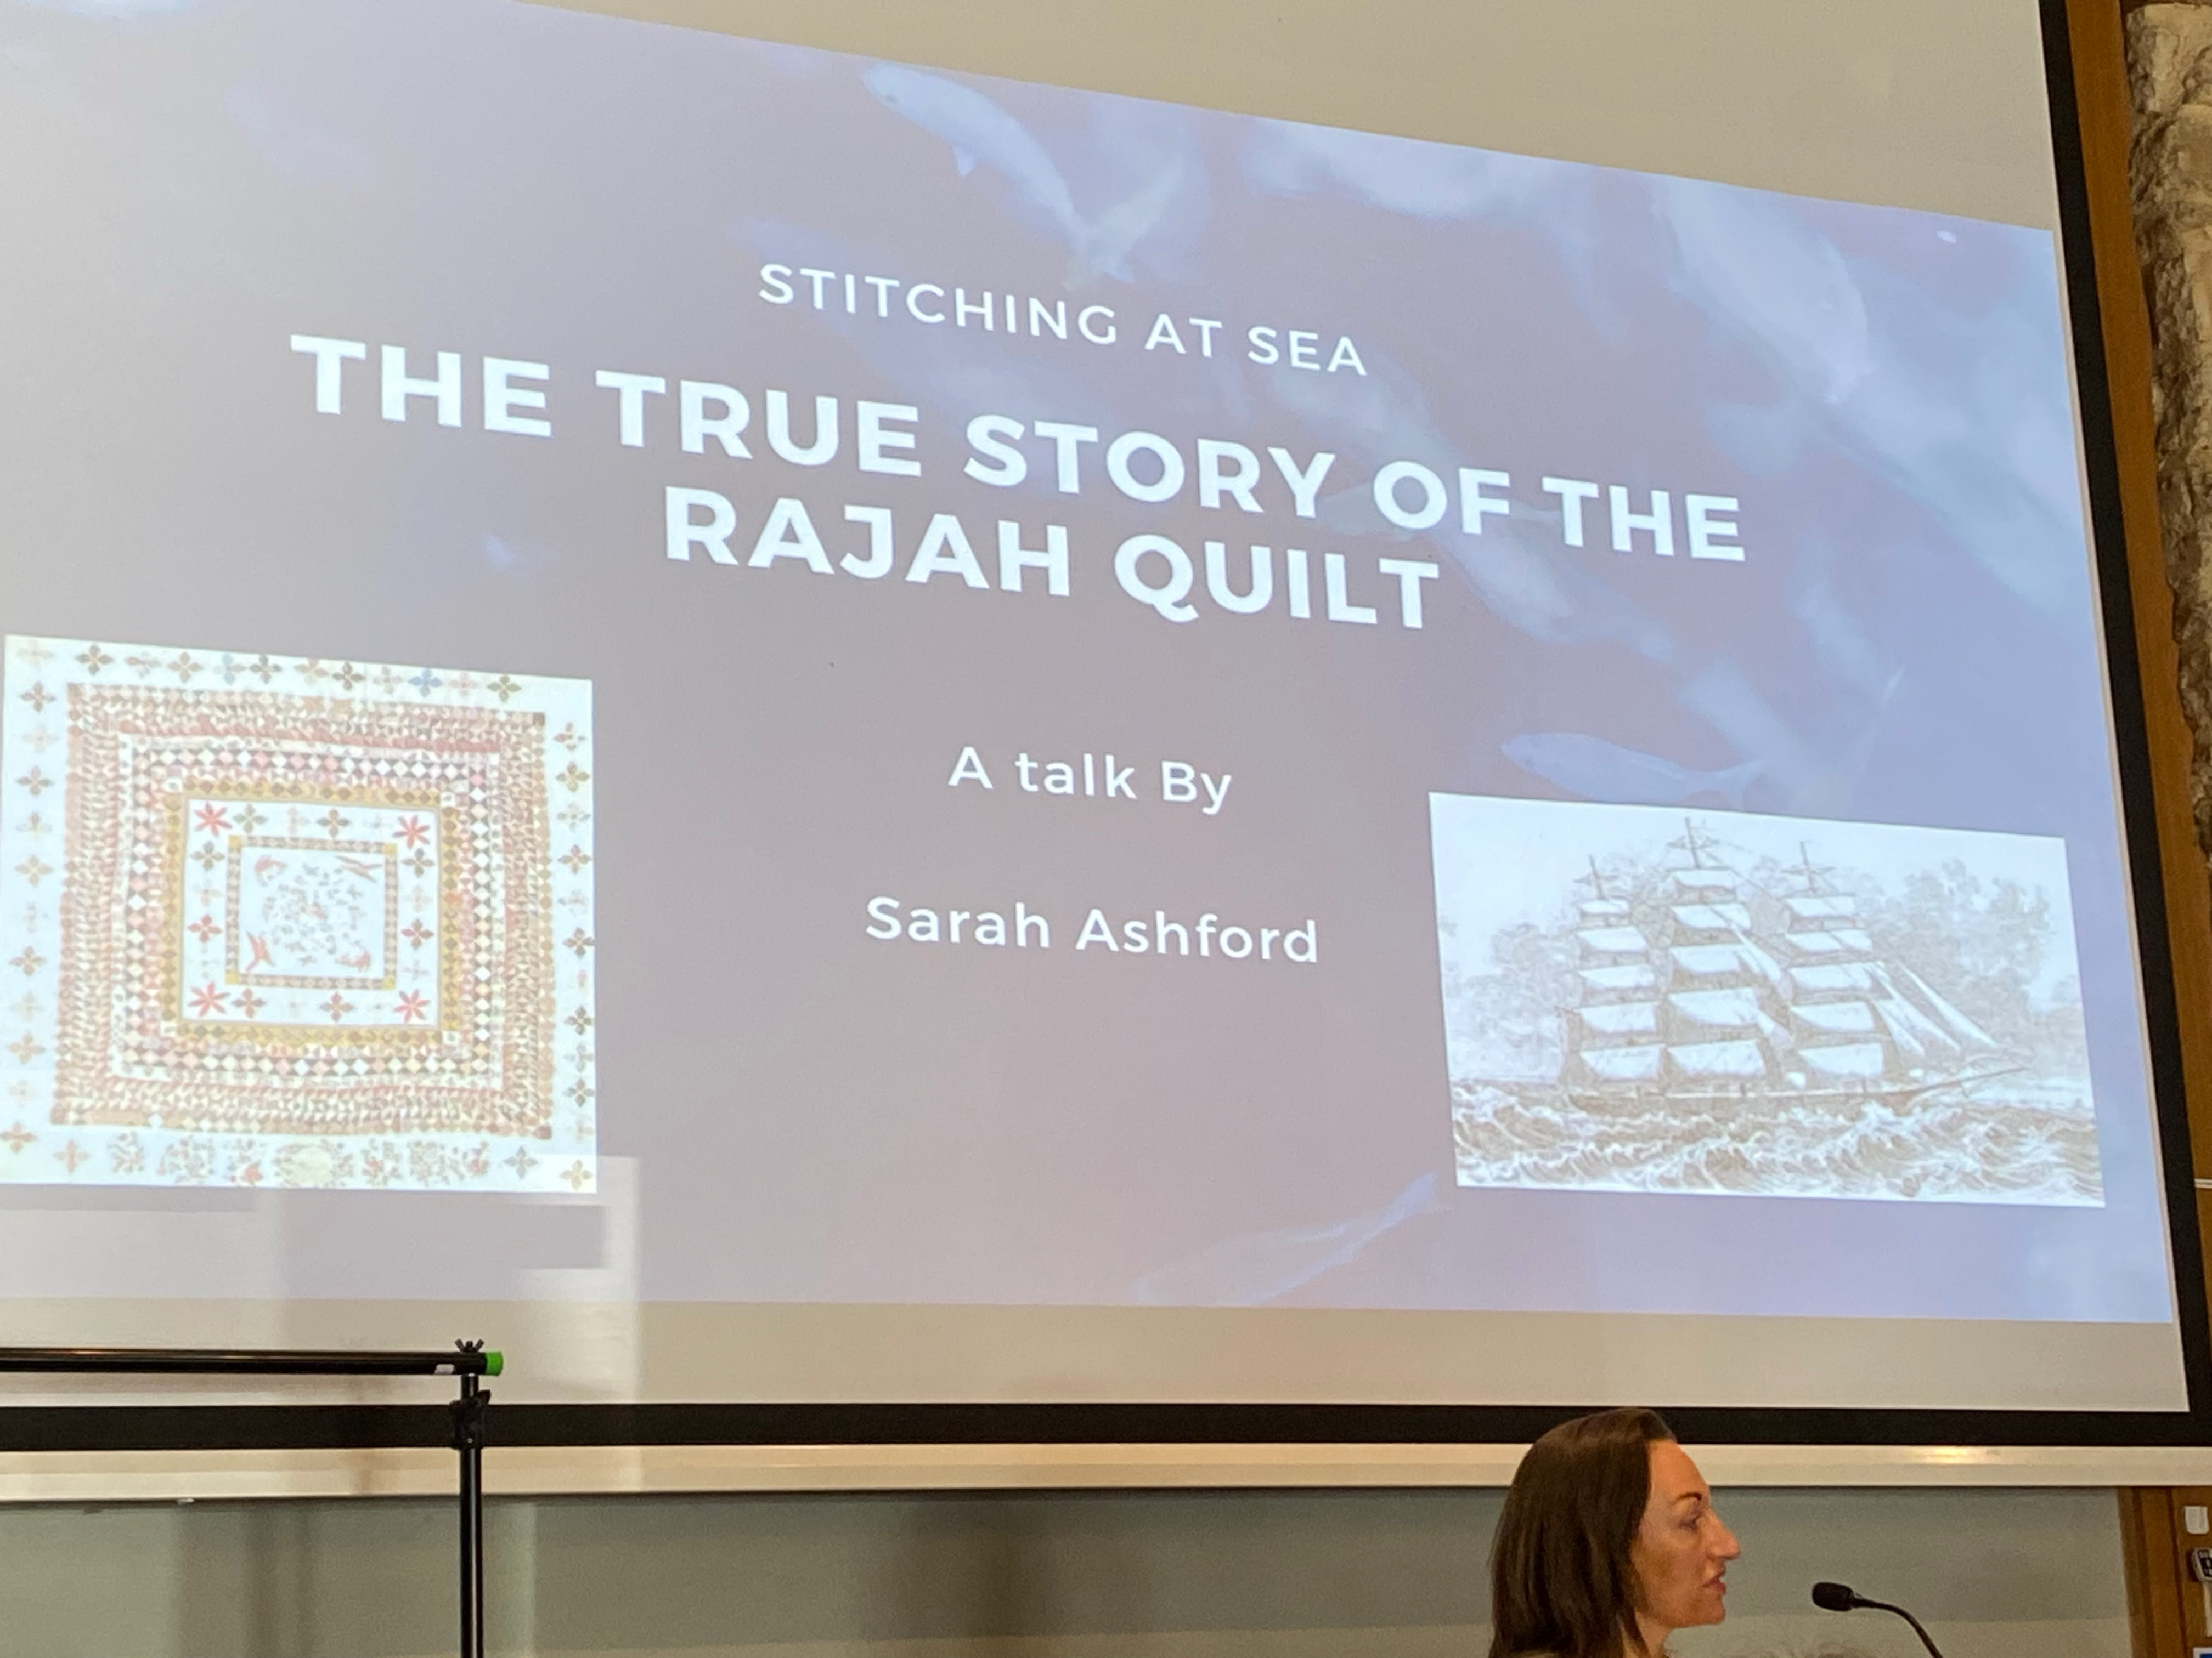
The day was hosted in Abingdon by the region 6 committee. Sarah Ashford was the speaker for the day and taught the workshop in the afternoon.
The trader was Crafty-UK
In the morning we had a presentation on the Rajah quilt.

The Rajah Quilt
In 1841 the Rajah convict ship sailed with 120 female prisoners for Australia. These women had been convicted of varied crimes, petty theft, prostitution and other minor offences.
At that time the Quaker Elizabeth Fry was working to improve the lives of female prisoners. She realised that if the women were given skills whilst in prison they were more likely to have better prospects on release.
Kazia Hayter, a friend of Elizabeth’s, was given a free passage on the ship if she taught the female convicts to sew.
The Rajah coverlet was the result of their efforts and was made during the long voyage. It is a medallion style coverlet with 2815 pieces and some blood splatters! This coverlet was given to the governor’s wife when the ship docked in Australia.
It was then sent back to England so that Elizabeth Fry could see it, but sadly she died before it arrived. Strangely, many years later it was found in an attic in Glasgow. Thankfully as its provenance was so well documented it was returned to Australia and now hangs in the national museum in Canberra.
Maybe we could get a trip together to go and see it.
This was followed by a show and tell. Shirlie Collier showed us her breakfast cereal quilt made for Linus using templates from Crafty-UK.
FYI Berkshire like the Linus quilts to be 40x60 inches.
In the afternoon we had a workshop on the Boro technique.
The day’s trader was Crafty-UK who had travelled from Kings Lynn. As they had made all that effort to come, we felt obliged to buy some of their wares. They are particularly known for their templates.
What a lovely was to spend a Saturday. Thank you Region 6 for organising this.
Jane S.

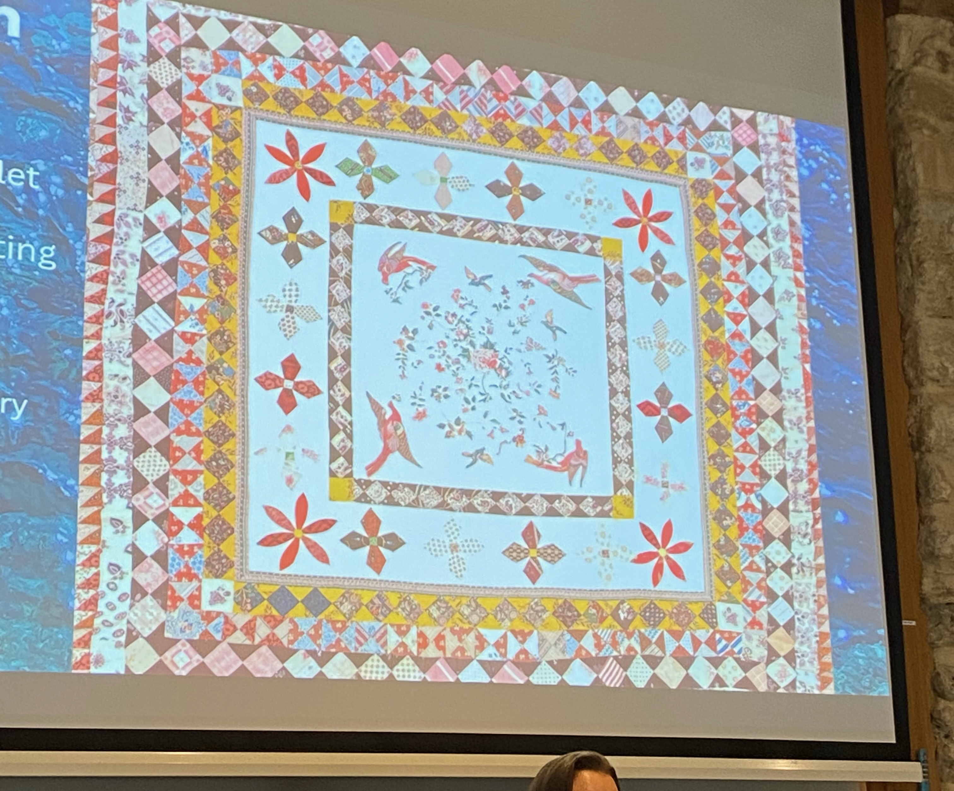
The Rajah Quilt. The only quilt made on the transportation ships to survive today.
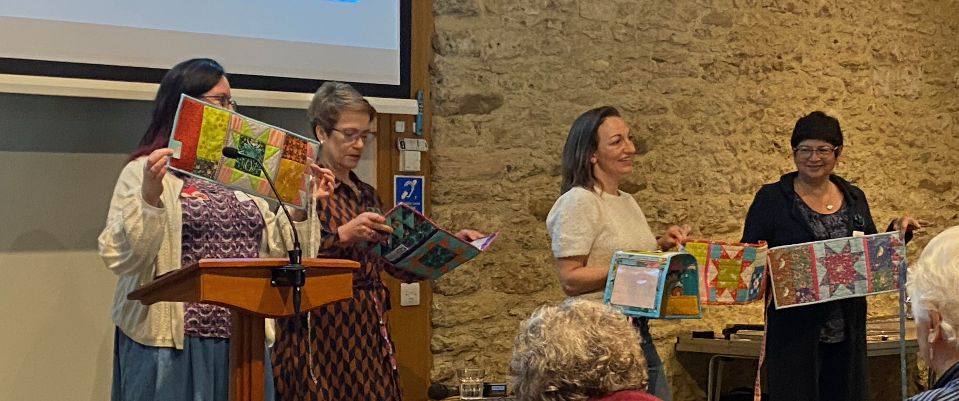Show and Tell.
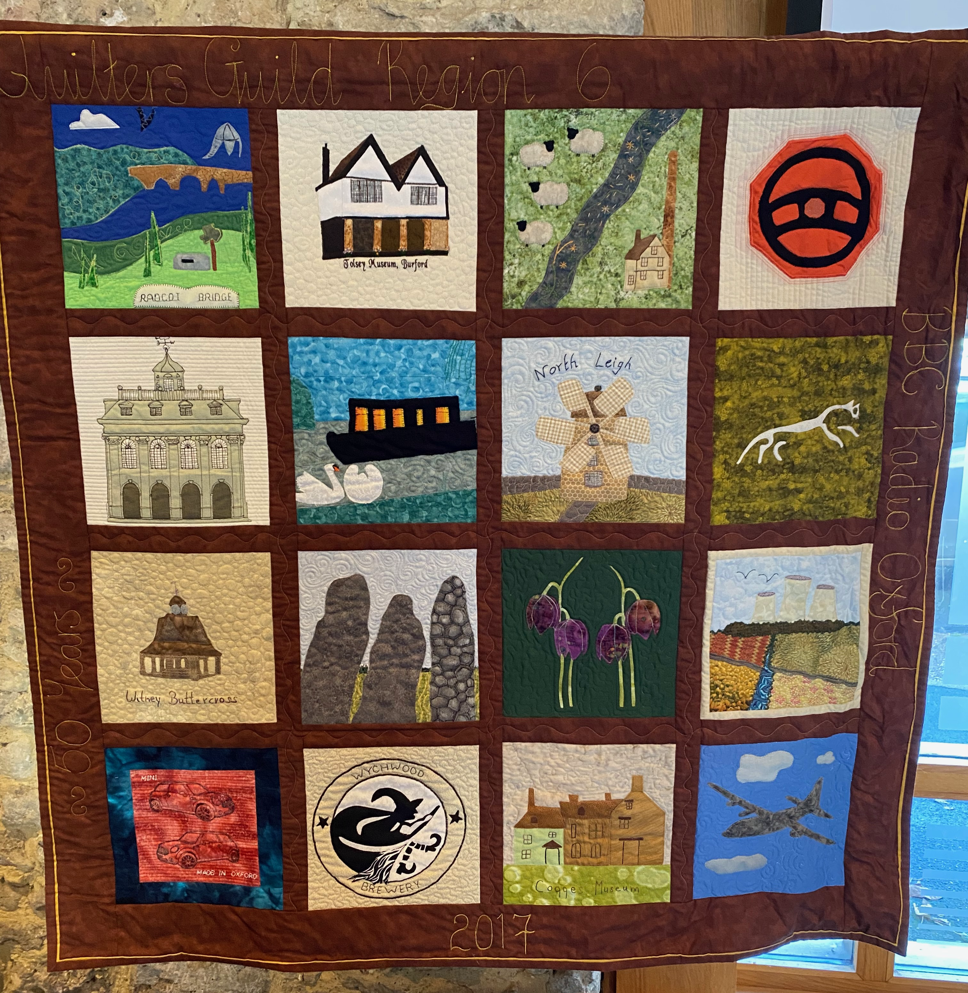
Region 6 Quilt
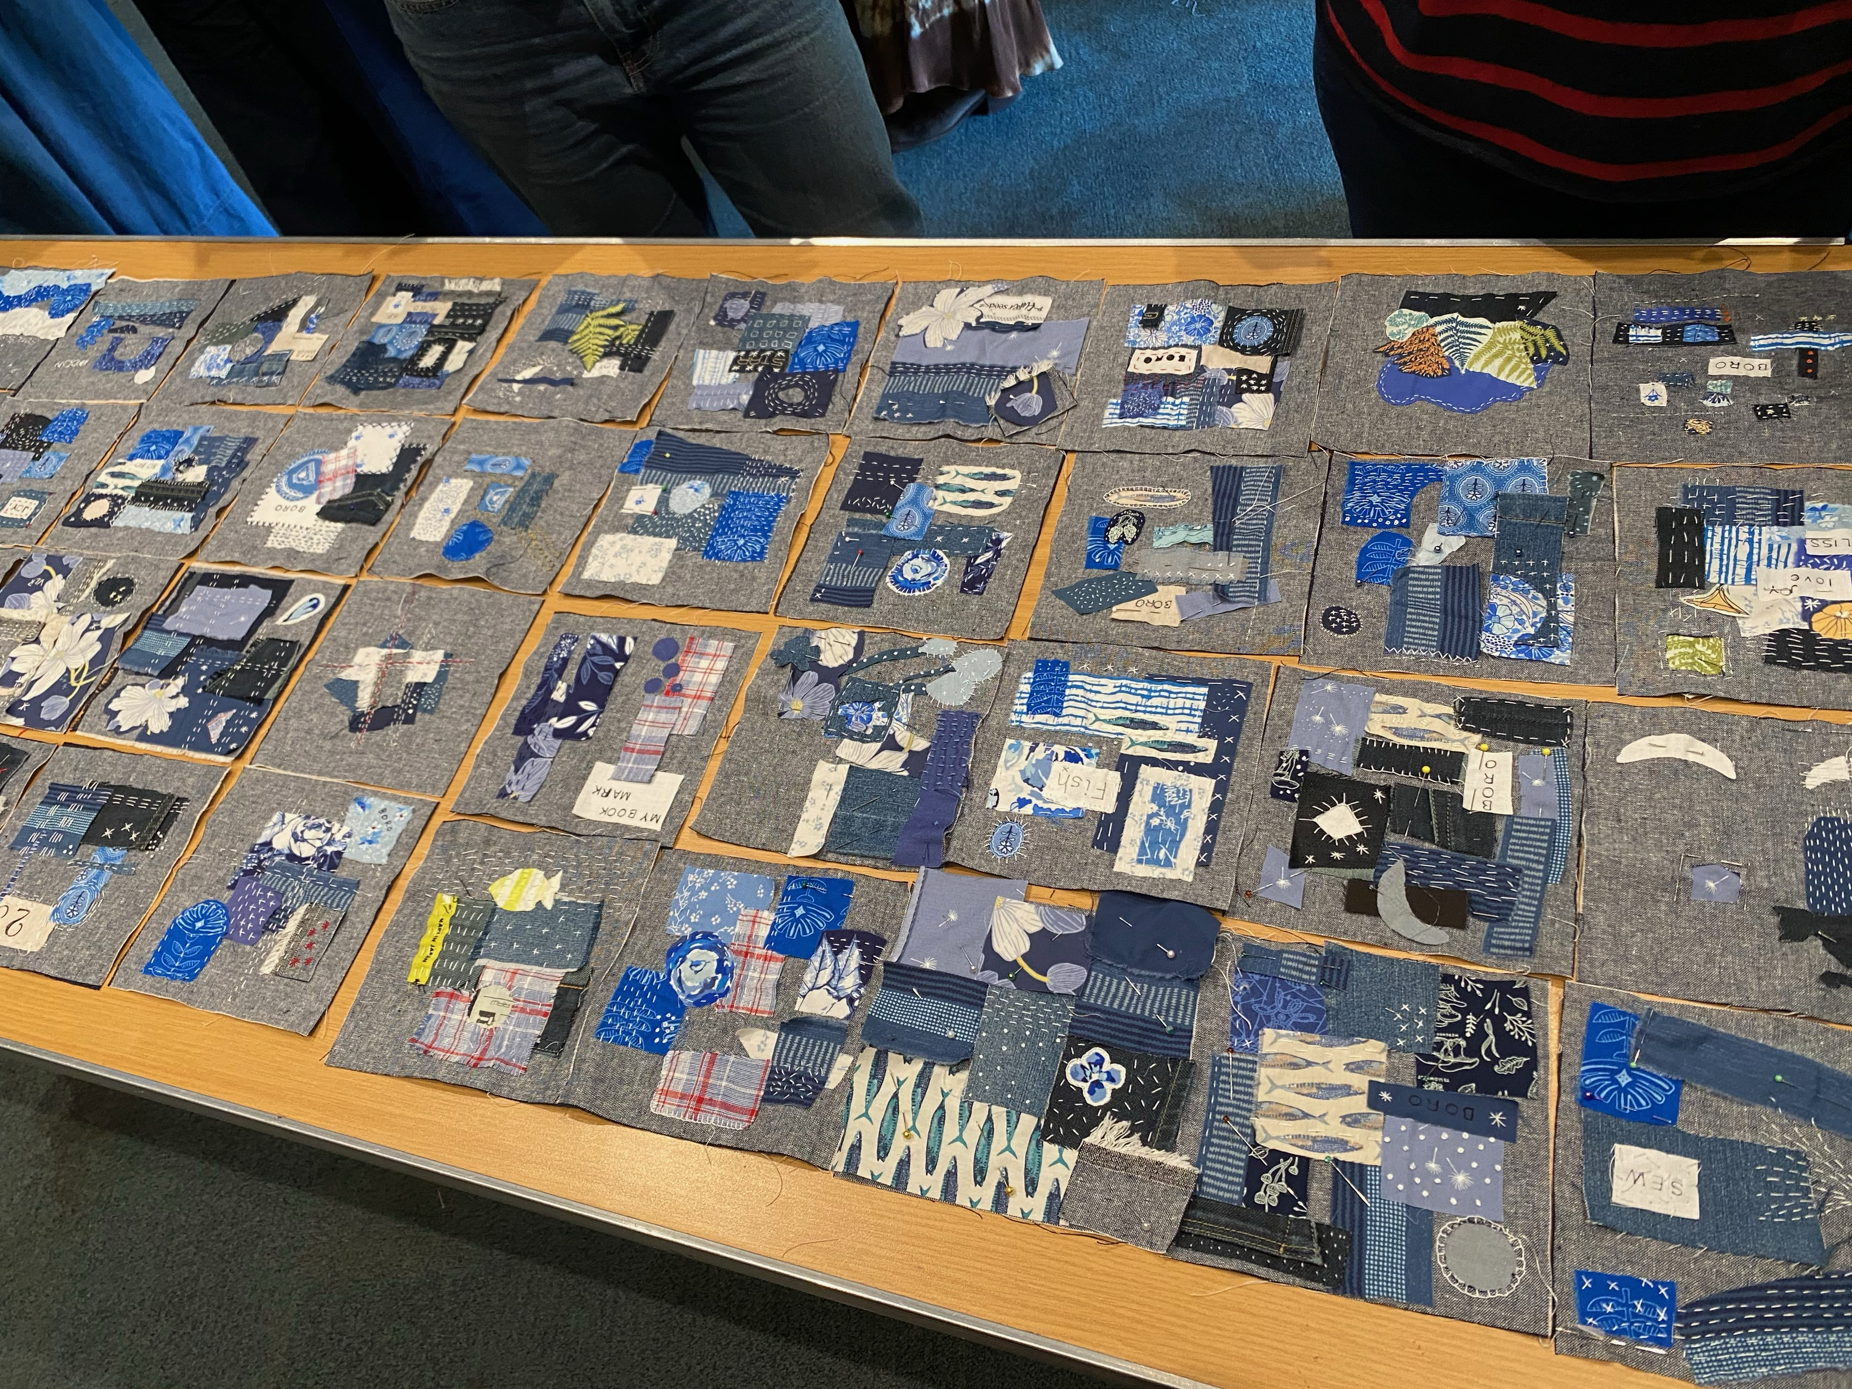
Some of the work produced in the afternoon workshop.

Kate Findlay Workshop

On Saturday, the 8th of November 14 members of our Market
Square Quilters group attended a workshop at Chieveley Village
Hall led by Kate Findlay
The morning began with Kate talking us through the process of
preparing the background for the Mini Wild Hedgerow workshop.
She had prepared a range of beautifully dyed pieces of fabric as
the base for us to print on. There was a wonderful selection of
stencils and wooden blocks for us to use with the fabric paints she
had brought along. She had painted pictures of birds for us to
choose from to use in our work.
After much deliberation, as we were spoiled for choice, we
decided upon the fabric and pictures we liked. We spent the rest of
the morning printing seed heads and foliage before applying the
next layer of appliquéd fabrics to create detail and interest.
After lunch we began to add detail with machine stitching or hand
embroidery.
At the end of the afternoon, we had a show of our work and Kate
gave us constructive ideas how to complete the pieces. She was
very impressed with all our work and undoubtedly we had all
created something rather beautiful. It proved to be a very
enjoyable day. Kate was a well organised and excellent tutor who
inspired and encouraged us every step along the way.
Gail W.
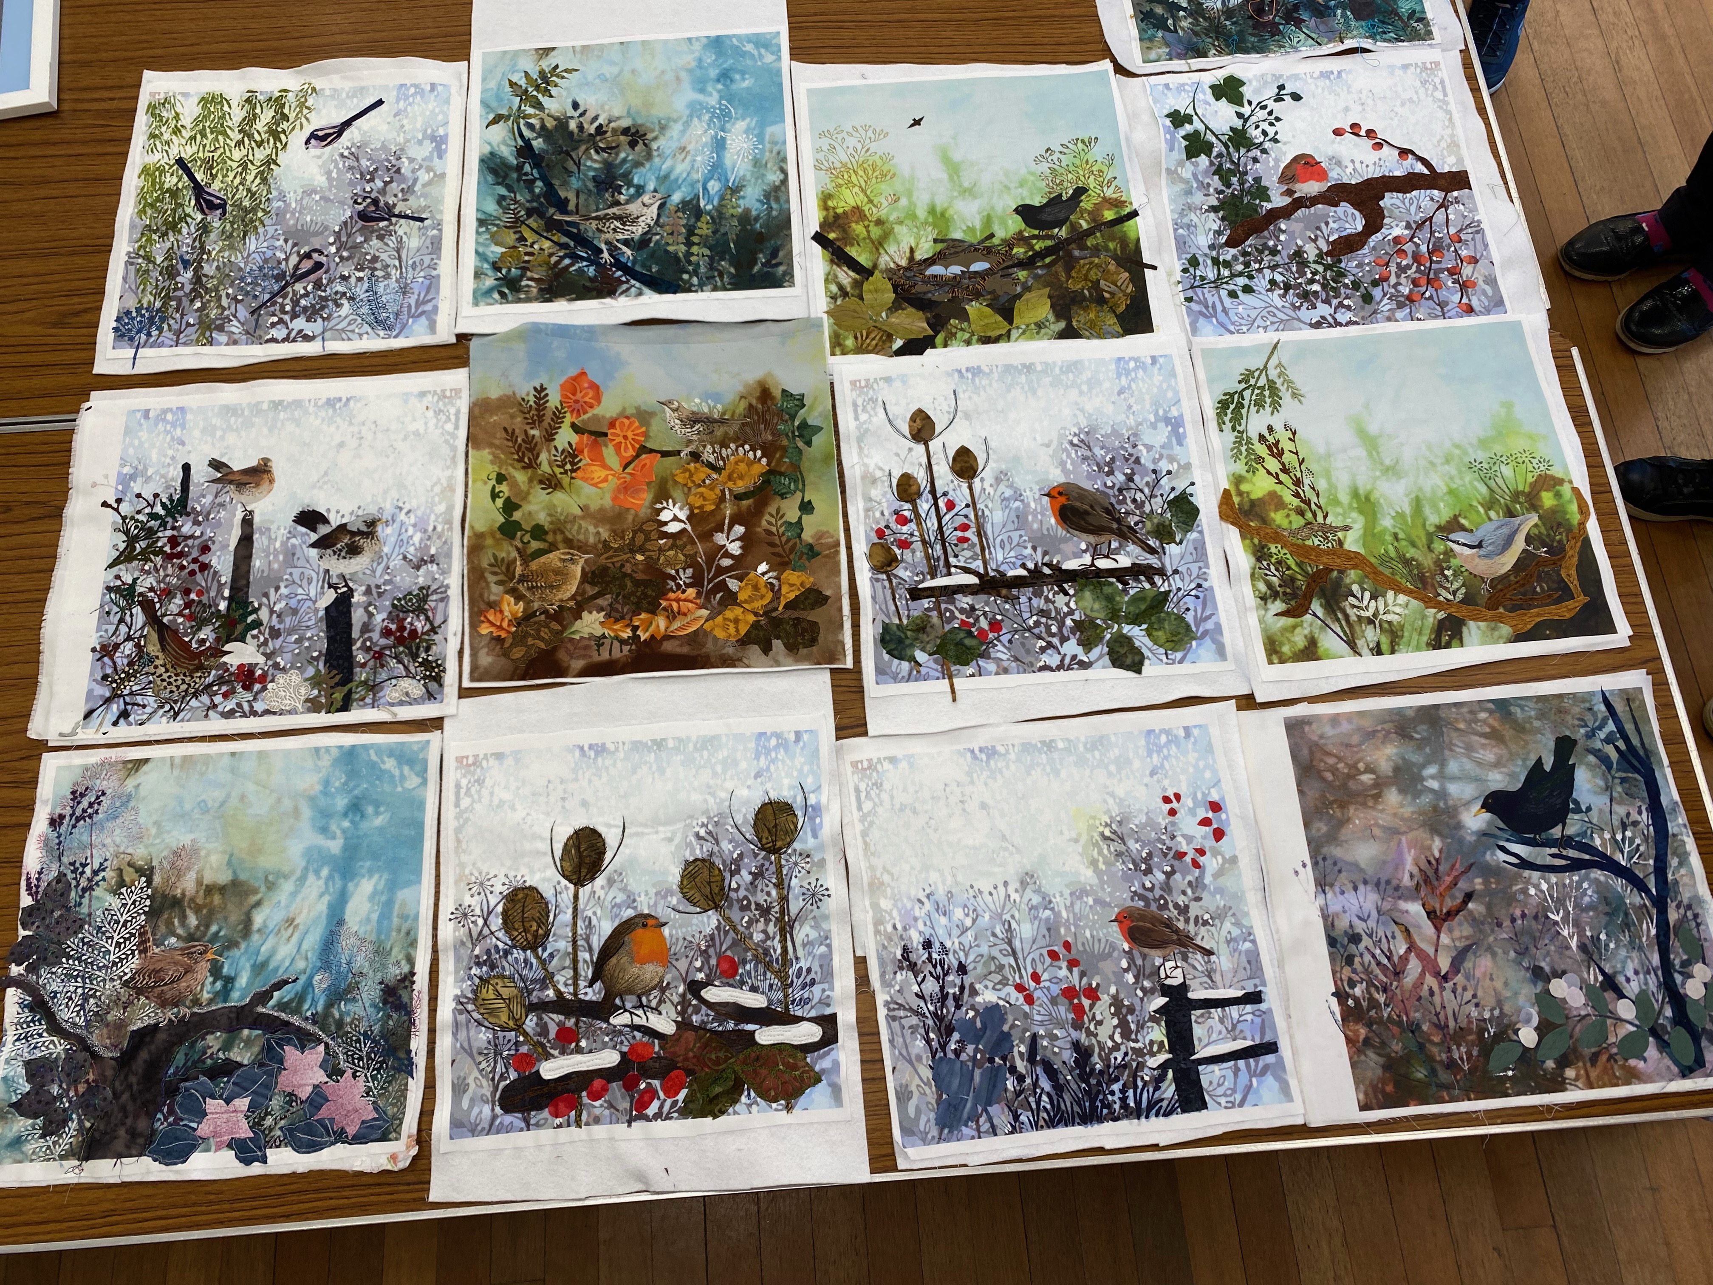
Some of the work in progress produced on the day.

Meet a Quilter - Caroline
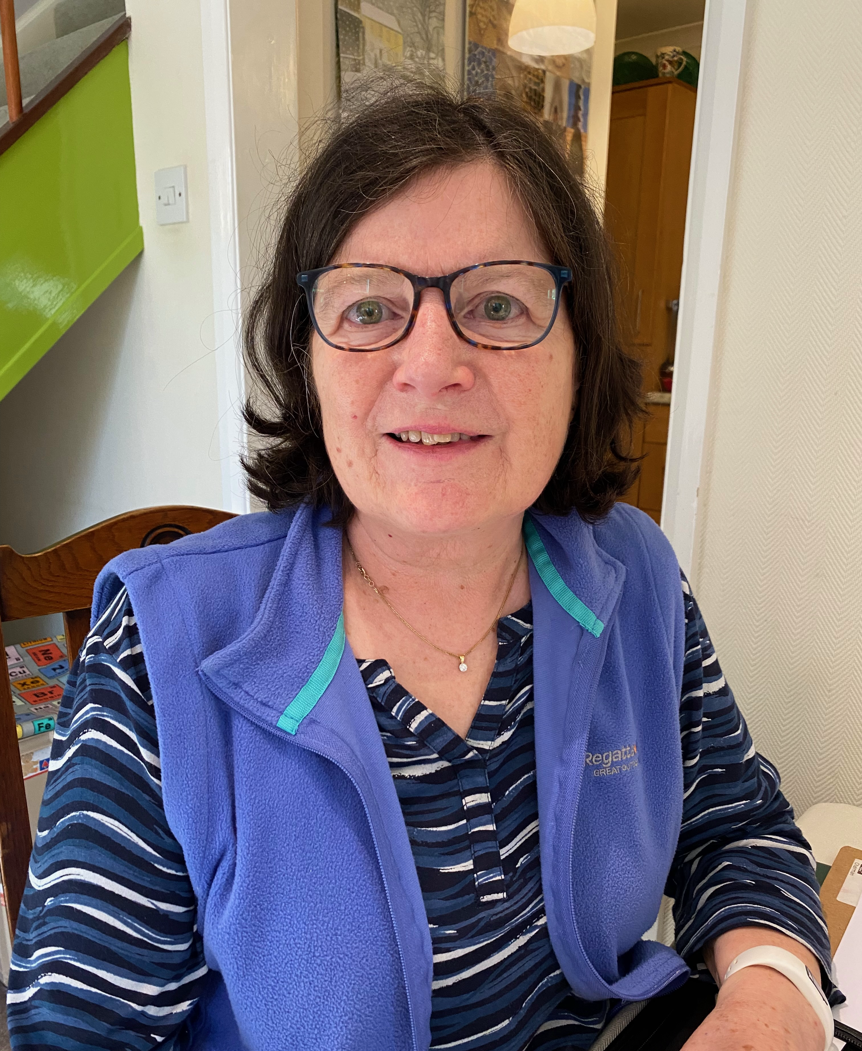

Caroline is a long-standing member of the group and she has served on the committee for a number of years, both as secretary and as editor of the newsletter, which used to be monthly. She is a familiar face in MSQ, often standing in for the chairperson.
Caroline was brought up in Scunthorpe and completed her education in the north, doing an art foundation course in Newcastle and later going to Loughborough College of Art to study ceramics. It was here that she met her engineering husband, Gordon, who was at the university. When he got a job at AWE she moved down to the Newbury area with him, living in Thatcham to begin with and later moving to Newbury itself over 40 years ago.
Caroline has sewn for as long as she can remember and learnt at her mother’s knee making clothes for dolls and teddies. She did an O level and an A level in needlework – those were the days when that was available! Caroline worked in Hungerford Arcade for three years and then in The Crafty Cat, a shop selling good quality crafts in Inch’s Yard for another three years before having children.
After her two children, a girl Patsy and a boy Alex were born, Caroline worked in a playgroup and then at the age of 40 did a two-year Nursery Nursing course at Newbury College. She got a teaching assistant job at The Castle School and worked there for 15 years.
About 18 years ago, Caroline saw a banner outside St Nicolas School where her children went, advertising a quilt exhibition. She decided to go and when she walked in the door and saw all Market Square Quilters’ beautiful work she immediately thought “I should be doing this”. She went along to a meeting, held in Wash Common Community Centre and joined the group. Shortly thereafter she became secretary and worked with Susan (who came to our anniversary party from Wales), Marianne and Sonia amongst others.
When she began quilt making, Caroline used left over scraps from her dressmaking but was soon tempted by the lovely fabrics available – it is very hard to resist buying fabric, as we all know! She likes the idea of recycling, having recently made quilts out of old shirts and ties. She is currently working on a Welsh strippy made from old duvet covers. She has done both hand and machine quilting but likes being able to hand quilt whilst watching the television. She is more inclined to make traditional designs that modern art quilts.
She says she is a ‘dabbler’ and will have a go at anything. Like many of us, in addition to dressmaking and ceramics, Caroline has also done cross-stitch, tapestry, smocking and watercolours. Though I don’t think many of us have done ceramics to be honest!
As far as future plans go, Caroline has ambitions to make a quilt to be exhibited. She has a friend who will be 70 next year and she is making a quilt on the theme of gardening for her. She also plans to make a single bed quilt for each of her four grandchildren for when they get older and is trying to use up some of her stash for this.
Thank you to Caroline for allowing me to interview her.

Wendy Lloyd – November Meeting Visitor
Wendy is a printmaker and textile artist who specialises in small stitched textiles. Her mother was also a textile artist so she has worked with fabric since childhood, specialising in fabric printing for school exams. Once married with children, she initially simply concentrated on household sewing such as clothing and curtains, but then she and her husband moved to Dubai where she joined the local Quilters Guild group. They had some very good speakers there and she learnt a lot from Jenny Bowker and Di Wells. When she moved back to the UK, she was drawn to the City & Guilds machine embroidery course and moved steadily into textiles and mixed media. She took a printmaking course at Rabley, near Marlborough. Then, in lockdown, she moved more towards hand sewing with scraps to make collages, using all of the skills she had acquired.
Wendy uses a variety of textures and colours; she likes to use scrap fabric which may have been used in the printing process and are blotchy as a result. She deliberately distresses scraps of fabric by leaving them in the garden or washing them in wash bags to encourage fraying. She even uses the small scraps of quilted fabric which she has tested stitching on. She collates her scraps into colours and keeps them in bags, then selects pieces from each colour and arranges them in different ways until she’s happy. She will use voile, sheers, cottons, paper, ribbon, silks and selvedges; she often uses L shaped pieces of paper to replicate a frame in order to see what the finished piece might look like. She then hand stitches onto the assembled collage to emphasise shape, bring a pop of colour or define an area. Stitches might be French knots, stem stitch, cross stitch, seed stitch or other simple stitches. She uses Pritt Stick to glue fabrics into place before stitching and may also back the collage with soft Vilene or brushed cotton.
Wendy exhibits at City Arts and joins Open Studios each year. Her website is www.wendylloydart.co.uk, and she can be contacted on wendylloyd.art@gmail.com or on 07990735769. She runs an email circulation list with information about forthcoming exhibitions: email her to join that list. She’s also on Instagram under @_wendy_lloyd
Sally

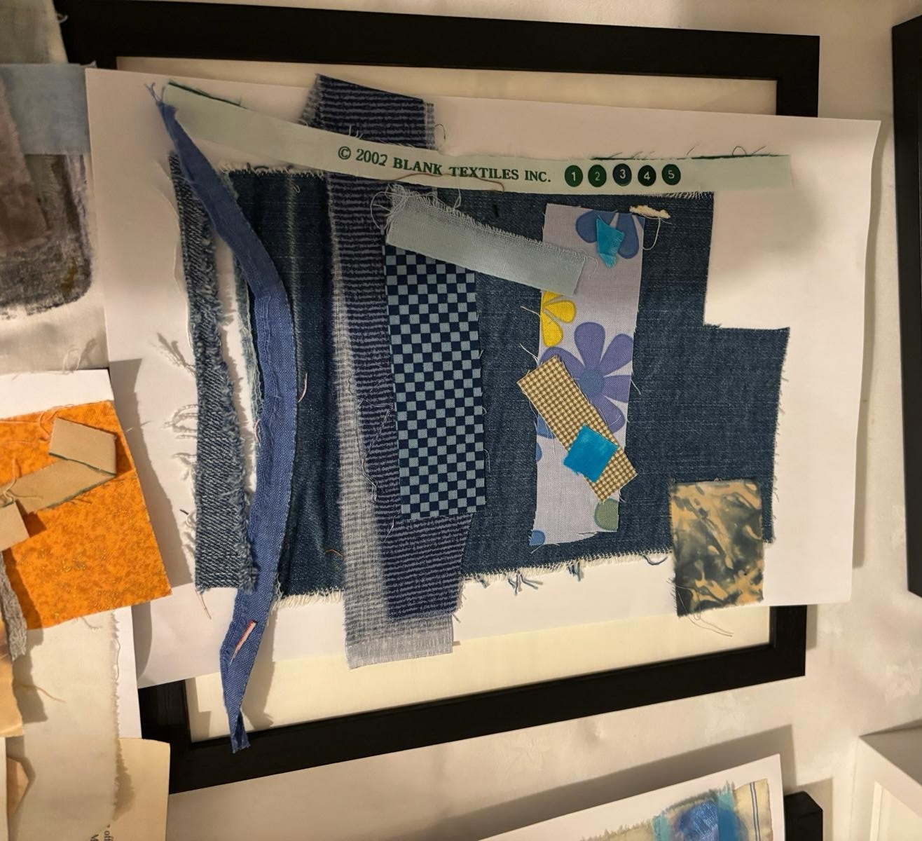
Work in progress
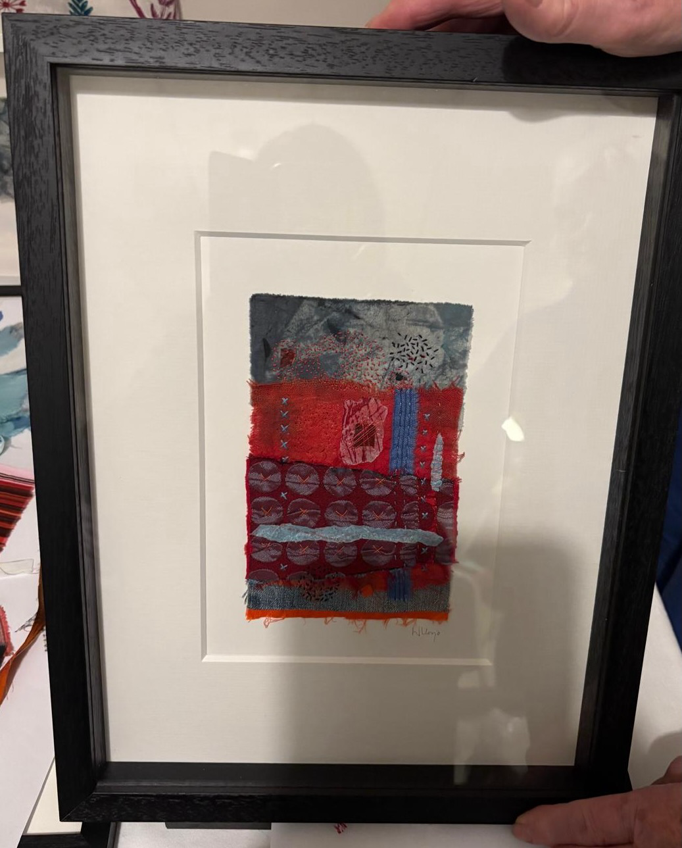
Two of Wendy’s finished pieces
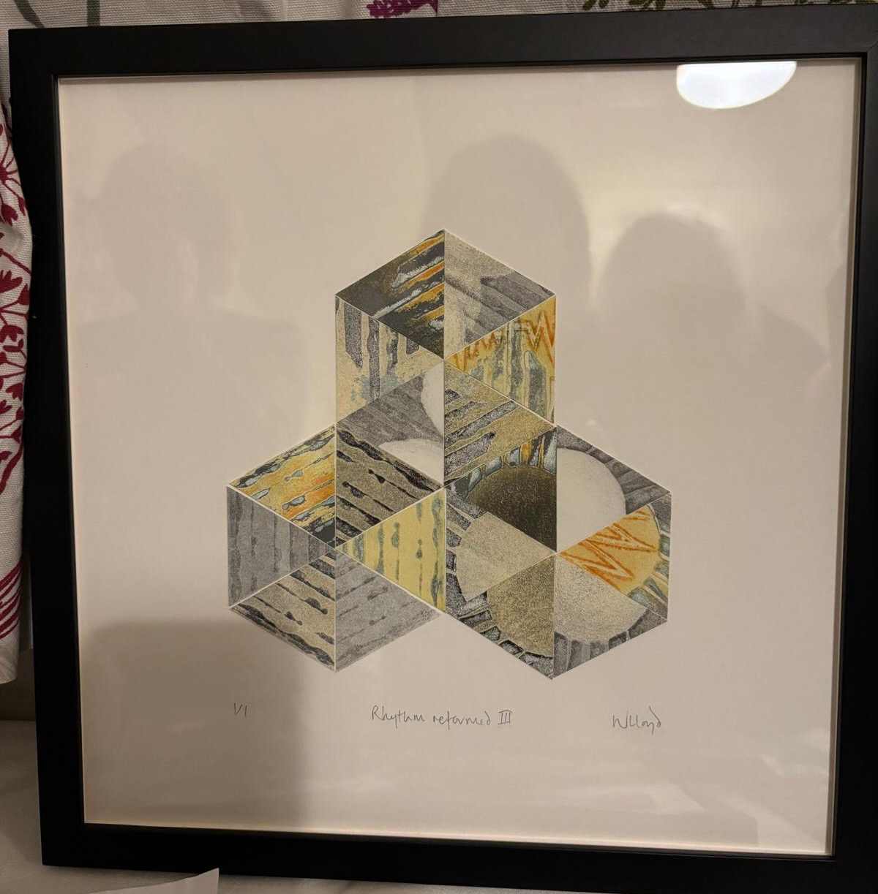

Finally, here are a few flyers for forthcoming events:

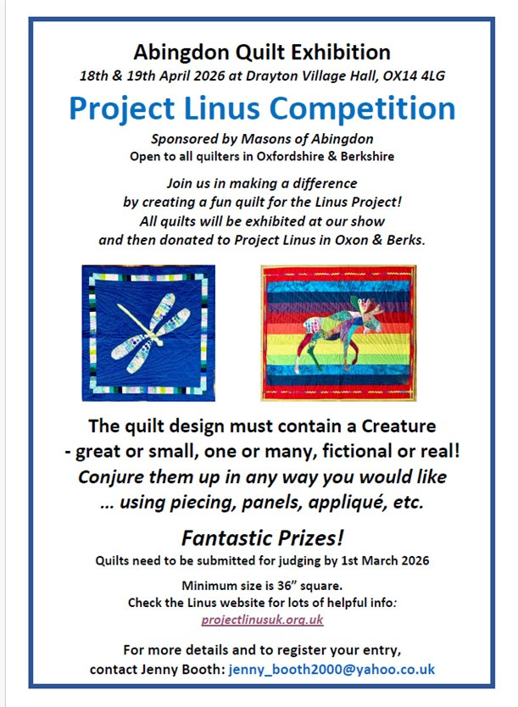

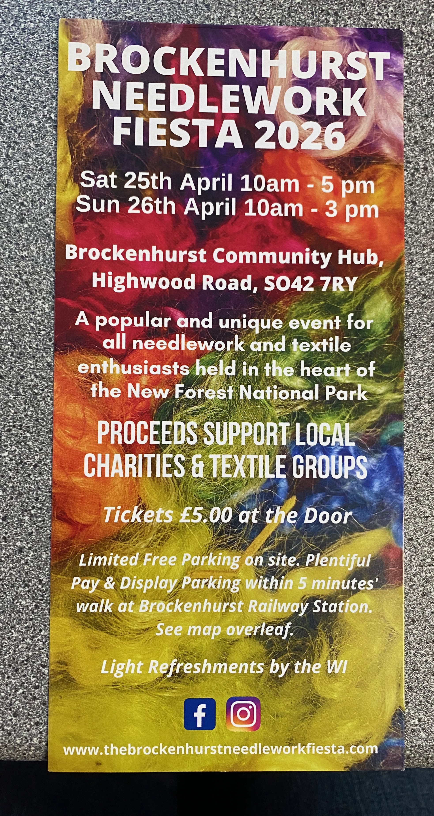

The Quilters ‘Guild

The Quilters' Guild has long been a source of education and friendship across the British Isles. We are an organisation powered by volunteers and loved by thousands.

We come together as a diverse group of individuals where abilities and differences are celebrated, the one thing that unites us all is our devotion to stitched textiles and of course, our quilting community!

The Guild is open to everyone with an interest in patchwork and quilting regardless of experience and skill, area of interest. Whether you are a beginner, an experienced quilter, textile artist, tutor or someone interested in the history and development of patchwork and quilting you are welcome to join us.
The Guild is a voluntary organisation with a small staff team. We are dependent on a host of volunteers to maintain and develop our activities both nationally and regionally. You can find out more about what is happening near you by visiting our regional pages or searching for an event based on your location.
The Quilters' Guild is the only UK charity dedicated to ensuring a vibrant quilting future. As an educational charity our aim is to enable members to develop their skills and explore new techniques and areas of interest. Our Special Interest Groups (SiGs) focus on contemporary, miniature, modern, and traditional techniques and are open to all members to join. The SiGs hold a mix of workshops and retreats with opportunities for members to exhibit. Join the Guild and join a group that specializes in your favourite style of quilting - or try something new. We have the resources that will help you broaden your interest and develop your skills.
The British Quilt Study Group researches all aspects of quilt making, historical and contemporary running seminars and study days. If you have wondered when fabrics became available or techniques fashionable or just the story behind a fabulous quilt this is the group for you.
We have a fantastic collection of quilted textiles both historic and modern that are exhibited, where opportunities allow, across the country. You can borrow a book from our extensive library or check out quilting stories in the Talking Quilts project.
Our shop reflects the items in our collection and features products like the Pattern Box series. This has been developed to provide an opportunity to learn a new technique set in a modern way based on a historic textile piece.
Whatever your interest you are most welcome to join us and join in our many activities.
Joining costs £57 per year.

